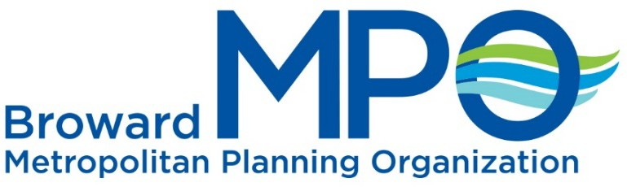

Broward MPO Complete Streets

Advisory Committee (CSAC) Meeting
Broward MPO – 100 West Cypress Creek Road, Suite 650 Monday, November 4, 2019 at 2:00 p.m. – 4:00 p.m.
Agenda
- Housekeeping 2:00 p.m.
  - Sign-In
  - Introductions
- MPO Current Efforts 2:10 p.m.
  - FHWA Bikeway Selection Guide Workshop
  - Let’s Go Walking! to School Day 2019
    - Tactical Urbanism Activity
    - Let’s Go Walking! Event
  - 7th Annual Safe Streets Summit– February 6th and 7th, 2020
- Broward MPO – Metropolitan Transportation Plan 2:25 p.m. Peter Gies, Systems Planning Manager
- South Florida Commuter Service-Transportation Demand Management 2:50 p.m. Jeremy Mullings, Senior Planner/Project Director
- Florida Department of Transportation- Context Classification 3:15 p.m. Larry Wallace, Bike/Ped/Complete Streets Coordinator
- Member Updates 3:40 p.m.
- Next Steps/Closing 3:50 p.m.
  - 2020 Meeting Schedule
  - Next meeting, January 13, 2020

Do not forget to visit the Complete Streets webpage, at:
www.BrowardMPO.org/major-functions/complete-streets-initiative


Move People & Goods | Create Jobs | Strengthen Communities
BrowardMPO.org

